Memo:

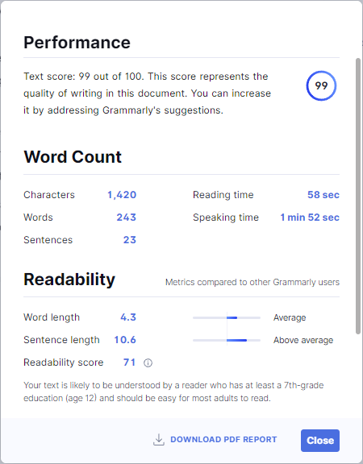

**To**: Mary Tripp <mtripp@jc-associates.com>

**From**: Jeff Watson <jeff.watson@jc-associates.com>

**Date**: September 25, 2022

**Subject**: Topic Proposal Approved

Mary,

This is to let you know that leadership approved my proposal for the semester-long project. I can move forward with my research and data capture. I appreciate your help and may very well take you up on your offer of assistance.

The 3-point shot made up 18% of all field goals in the 1999-2000 season. That percentage rose to more than 39% in the 2019-2020 season, and team owners expect the profits to continue climbing. NBA revenue was $2.5B in 2001. There was a slow, steady rise over the next decade. After a dip in revenue in 2012 related to labor negotiations and a shortened season, the league's revenue increased by at least 8% every season until COVID put games on pause.

As I alluded to earlier, this is a fantastic opportunity for our clients. The intelligence derived from showing the correlation between 3-pointers, in terms of volume and efficiency, and revenue will help drive decision-making before the draft and going into free agency.

I'm excited about this opportunity. I'm looking forward to the research and the findings that come with it.

Best,

Jeff Watson

Data Scientist

Jordan, Curry, and Associates

Email

